Here is Q-Tools 2.0. I updated it for Vault 2012 and hopefully fixed the multi-site issues. I also added, by request, the ability to email multiple addresses when errors are detected.
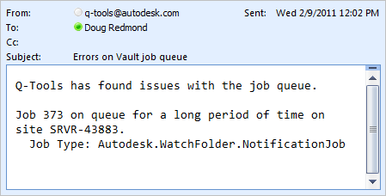
Here is the full feature list:
- Logging - Issues are logged to a text file.
- Stale Job Detection - Jobs on the queue too long can be considered an issue.
- Email Reports - Issues can be emailed to one or more recipients.
- Queue Cleanup - Jobs with issues can be automatically removed from the queue.
- Queue Forwarding - In multi-site and multi-workgroup environments, jobs can get routed to a single site.

Requirements:
- Vault Workgroup/Collaboration/Professional 2012
- Job Server feature enabled
Click here to download the application
Click here to download the source code

To setup:
- Designate a computer on the network that the Q-Tools service should run on. Only 1 Q-Tools can be running for a given Vault deployment.
- Run the installer.
- Go to the installation folder and update the settings.xml. The XML comments will explain this step.
- Run the Q-Tools service.
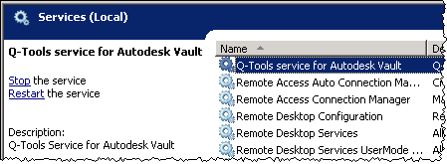
As with all the samples on this site, the legal disclaimer applies.

